MATHEMATICS FOR

ELECTORNIC ENGINEERS(UE21EC242A)

PROJECT REPORT

WEIBULL DISTRIBUTION-REAL LIFE APPLICATIONS

PROFESSOR: Ms RAJINI M.

AKASH RAVI BHAT(PES1UG21EC025)

A.ANIRUDH SIMHA(PESUG21EC001)

WEIBULL DISTRIBUTION:

The W**e**ibull Distribution is a continuous probability distribution used to analyse life data, model failure times and access product reliability. It can also fit a huge range of data from many other fields like economics, hydrology, biology, engineering sciences. It is an extreme value of probability distribution which is frequently used to model the reliability, survival, wind speeds and other data.

The only reason to use Weibull distribution is because of its flexibility. Because it can simulate various distributions like normal and exponential distributions. Weibull’s distribution reliability is measured with the help of parameters. The two versions of Weibull probability density function(pdf) are

* Two parameter pdf
* Three parameter pdf

The parameters are :

* γ

is the shape parameter, also called as the Weibull slope or the threshold parameter.

* α

is the scale parameter, also called the characteristic life parameter.

* μ

is the location parameter, also called the waiting time parameter or sometimes the shift parameter.

The standard Weibull distribution is derived, when μ=0 and α =1

For 2 parameter weibull distribution the location parameter (neu) is not included.

For 3 parameter weibull distribution all 3 parameters are included.

WEIBULL DISTRIBUTION PDF GRAPH:

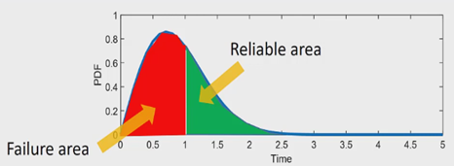

WEIBULL DISTRIBUTION CDF GRAPH:

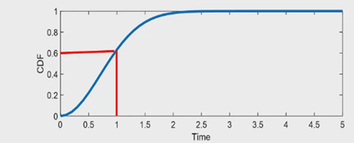

APPLICATIONS:

The Weibull distribution is used

* In [survival analysis](https://en.wikipedia.org/wiki/Survival_analysis)
* In [reliability engineering](https://en.wikipedia.org/wiki/Reliability_engineering) and [failure analysis](https://en.wikipedia.org/wiki/Failure_analysis)
* In [electrical engineering](https://en.wikipedia.org/wiki/Electrical_engineering) to represent overvoltage occurring in an electrical system
* In [industrial engineering](https://en.wikipedia.org/wiki/Industrial_engineering) to represent [manufacturing](https://en.wikipedia.org/wiki/Manufacturing) and [delivery](https://en.wikipedia.org/wiki/Delivery_(commerce)) times
* In [extreme value theory](https://en.wikipedia.org/wiki/Extreme_value_theory)

MATLAB IMPLEMENTATION:

Example 1:Find:

* 1. P(x>20000)
  2. P(x<10000)
  3. P(10000<x<20000)
  4. Expected time to failure

Given gamma=0.5 and alpha=5000

Solution:

%% Example Flat display

clc; clear;

alpha= 5000; gamma= 0.5;

p20k_below= wblcdf(20000, alpha, gamma)

p20k_beyond = 1- p20k_below

p10k_20k = wblcdf (20000, alpha, gamma) - wblcdf (10000, alpha, gamma)

[M, V]= wblstat (alpha, gamma)

time= 1:100:25000;

subplot (211); fx= wblpdf (time, alpha, gamma);

plot (time, fx, 'linewidth', 2.5); xlabel('Time'); ylabel('Weibull PDF Display');

subplot (212); ft= wblcdf (time, alpha, gamma);

plot (time, ft, 'linewidth', 2.5); xlabel('Time'); ylabel('Weibull CDF Display');

output:

we see that 10000 hour is mean failure time .

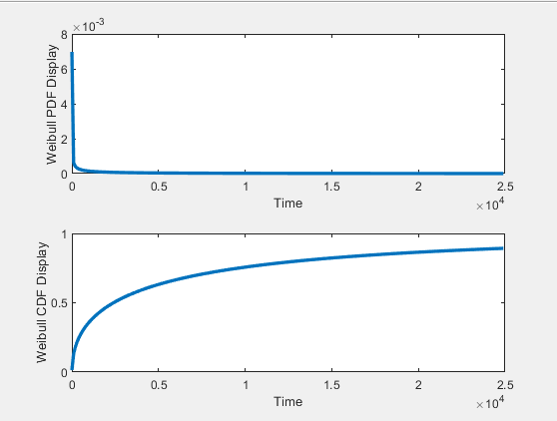

Example 2

Given 20000 tyres what percentage of tyres fail before running 6000km.

Alpha=5000 gamma=3.5

Solution:

%% Example Tire Weibull Distribution

clc; clear;

alpha = 5000; gamma = 3.5;

TotalTires= 20000;

y= wblcdf (6000, alpha, gamma)

FailTires= y*TotalTires

time =1:10:10000;

subplot (211); fx = wblpdf (time, alpha, gamma);

plot (time, fx, 'linewidth', 2.5); xlabel('Time'); ylabel('Weibull PDF Tire');

subplot (212); ft = wblcdf (time, alpha, gamma);

plot (time, ft, 'linewidth', 2.5); xlabel('Time'); ylabel('Weibull CDF Tire');

output:

we see that 85% of the tyres fail before 6000km

which is 16987 of 20000 tyres.

